Anonymous Archival Authority: Information Profile
This information profile has been developed from interviews conducted at the Anonymous Archival Authority (AAA) in 2015, supplemented by information publically available from the AAA website http://*** It begins by providing a brief background, and then reports observations from the perspective of the three levels of the information culture model. .

Background
AAA is responsible for leading the implementation of the government’s digital transformation policy and is actively developing standards and guidelines to support agencies within its jurisdiction to meet the ambitious targets of paperless working environments across government within the next decade.
AAA has traditionally been perceived as an early adopter of technology, largely as a result of implementing an electronic document and records management system (EDRMS) in the late 1990s. In 2010 whole of government budget cutbacks resulted in significant internal restructuring, with the loss of forty full time equivalent positions (20% of the overall staffing complement). Subsequent staff turnover has been very high, and many of the new employees (including those at senior management level) recruited do not have a background in archival practice or experience of the cultural heritage sector.
To gain an overview of the values of the organisation, interviewees were asked to select from a list of words those that were most characteristic of their workplace. All staff selected the words professionalism, accuracy, and customer-orientation. These reflect the fact that high levels of accuracy are required when working with archival records, and that staff are very engaged with the users of AAA. The word cloud below shows the mix of words in this exercise, and the keywords when asked to describe the culture of the organisation.
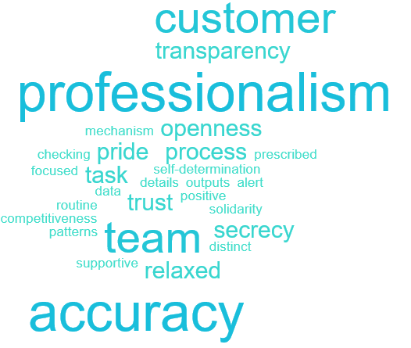

Level One Observations
Features observed at this level are fundamental influences impacting on the ways in which information is managed. They may not be possible to change, but must be clearly identified in order to develop strategies and solutions that are appropriate to the context. The factors to be taken into consideration at this level are as follows:
- The value (or respect) accorded to information of different types. This will include recognition and awareness of the need to manage certain information for the purposes of accountability, as well as for the purposes of facilitating knowledge and awareness.
- Preferences for different communication media and formats, as well as preferences with regard to sharing information. The former involves consideration of preferred primary sources for information; the latter, the level of granularity to which information sharing is regarded as the norm by employees.
- Language requirements. What happens when multiple languages are required or when one language becomes dominant.
- Regional technological infrastructure. The technological infrastructure in the country or region that the organisation is located in.
Value Accorded to Information
- A very high level of recognition of the need to file records in the EDRMS was evident across almost all (but not the whole) organisation, although this recognition was not always translated into action
- A narrow conceptualisation of records was evident, based on analogies to the paper world (e.g. non text and/or complex digital objects unlikely to be perceived as ‘records’).
- Emails constitute a significant area where people rely predominantly on their own ‘archives’, but there was clear awareness that best practice would be to manage them in a central repository.
Information Preferences
- Preferences for oral communication very evident
- Long term employees regarded as primary source for authoritative information
Information Flows
- Top-down information flow
- In some parts of the organiation there were tendencies to hoard, to protect ‘their’ information from the eyes of others or simply to develop own set of files for team/workgroup
- Tendencies to overly protect, to assign unnecessary security classifications
Languages
- A small number of finding aids available in local indigenous languages, otherwise English used as the lingua franca.
- Significant problems experienced in communication between the archivists and non-archivists
Regional IT Infrastructure
- Lack of broadband nationwide necessitates regional offices developing ‘shadow’ systems and repositories

Level Two Observations
The second level of the pyramid represents the skills, knowledge and expertise of employees relating to information management, which can be acquired and/or extended in the workplace. This is placed in the middle of the triangle because training development will take into account those fundamental influences at the bottom. The skills, knowledge and expertise can be divided into two broad categories:
- Information related competencies, including information and digital literacy.
- Awareness of environmental (societal and organisational) requirements relating to recordkeeping.
Information Related Competencies
- In some departments, use of digital rather than analogue tools (e.g. spreadsheets instead of registers) minimal or non-existant.
- High awareness of vulnerability of digital files
- Need for understanding of file format complexity and size issues, and consequences of network operations
- Different perceptions of risk which could be addressed with training
- Different understanding of when and how to capture emails, including what should happen to attachments

Awareness of Societal/Organisational Requirements
- Awareness of shared drive environment policy and procedures not widespread
- Inappropriate use of security classifications should be monitored and addressed with training
- Need to differentiate training requirements for new and long term employees, and determine most appropriate delivery modes

Level Three
At the tip of the pyramid are two organisational features which are highly significant for successful recordkeeping and are the most susceptible to change. These two features are:
- The information governance model that is in place in the organisation, as reflected in the organisation’s information technology infrastructure.
- Trust in organisational recordkeeping systems.
ICT Governance
- Tools to support mobile working not fully implemented
- Email quota/in box size policy overly restrictive, promotes reactive behaviour (mass deleting)

Trust in Systems
- There was considerable mistrust of the EDRMS, and reference to it being a ‘black hole’

Last Words
AAA’s information culture is transitioning from a paper paradigm to a digital environment, characterised by extremes. On one side, resistance to digital tools and indeed change in general, and on the other, pockets of real innovation, creativity and leadership. A key strategy going forward has to be the establishment of a consistent, minimum standard of digital literacy across the whole organisation. The implementation of digital tools, technologies and appropriate policies which support mobile working will be another essential component for successful transition.
Undertaking a comprehensive audit of AAA business processes will be beneficial in terms of highlighting areas where efficiencies can be introduced, for example identifying where systems overlap or where systems could be integrated. This will assist with upskilling staff with business process analysis skills, and also help to harmonise different procedures that are currently being followed to achieve the same objectives. The audit could consist of the following steps:
- Identify business process
- Define purpose of process
- Identify personnel involved
- Document each step, indicating systems involved (manual and computer)
- Evaluate whether each step is necessary, whether refinements are possible, and where automated tools can be used to replace manual components.
- Identify related processes and evaluate the feasibility of consolidation
- Promote negotiated and agreed process for uptake by all employees involved
Of concern is the gap in understanding which exists between those with a professional archives background and those without. Consideration should be given to developing a staff rotation programme which would not only contribute to the upskilling required, but also help mitigate against the perceived siloed nature of the organisation.

